Contents
I. Introduction 2
1. Purpose 2
2. Scope 2
3. Overview 2
4. Abbreviation 2
II. Acceptance Testing 2
1. What is Acceptance testing 2
2. Who does Acceptance testing 2
3. Acceptance testing process 3
III. How to design Acceptance test cases 3
1. ATC Design Flow 3
2. ATC format 4
3. ATC expectation 4
4. Entries and Exit criteria 5
IV. How to execute Acceptance testing 5
1. ATC Execution Flow 5
2. Entries and Exit criteria 6

Introduction

Purpose
The goal of this Acceptance testing guideline is to outline Acceptance testing process which helps Developer to understand how to create and execute Acceptance test cases.

Scope
This guideline is used for Acceptance testing.

Overview
This document is separated into 4 parts:
- Introduction
- Acceptance testing
- How to design Acceptance test case
- How to execute Acceptance testing

Abbreviation
Term | Concept
AT | Acceptance testing
ATC | Acceptance test case
SRS | Software requirements specifications

Acceptance Testing

What is Acceptance testing
Acceptance testing is a method where testing of each component (a function, a module, a screen) in an application is done separately. Acceptance testing performed to ascertain that user interface is designed correctly and all functionalities of the component is working fine as software requirements mentioned in the specification document.

Who does Acceptance testing
Acceptance testing is performed by Developer on the development environment, before Integration testing is performed by Tester.

Acceptance testing process
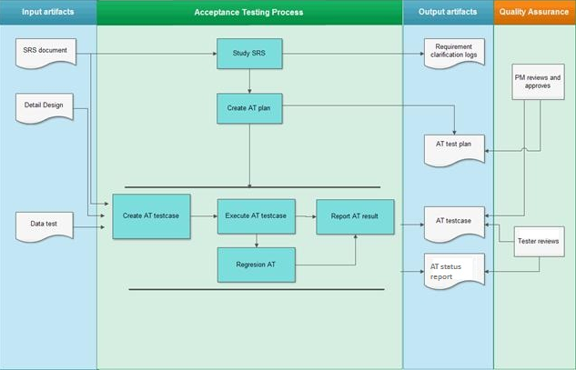

How to design Acceptance test cases

ATC Design Flow
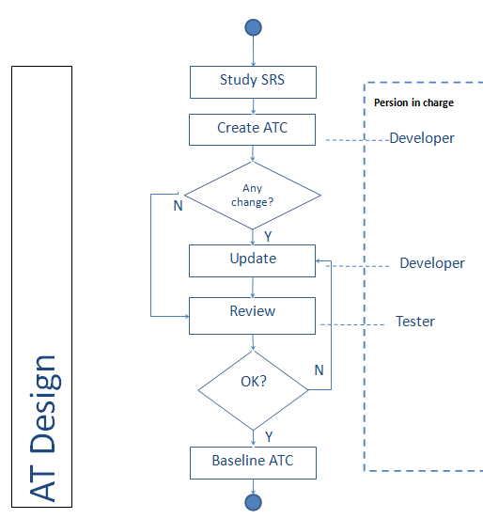

ATC format
- Use Excel sheets to write the test cases with format as below:
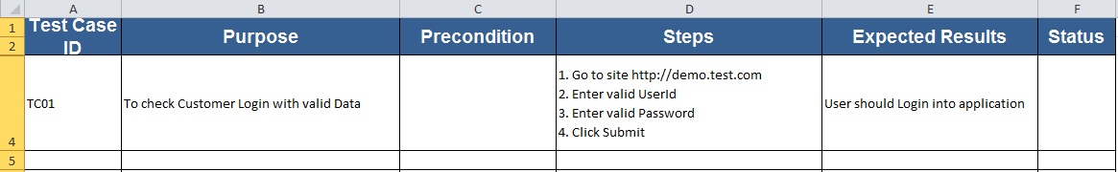
- In that:
Test Case ID | The ID of the test case. It’s unique.
Purpose | The summary / objective of the test case and usually begins with “To check” or “To verify” keywords.
Precondition | Any prerequisites or preconditions that must be fulfilled prior to executing the test.
Steps | Step-by-step procedure to execute the test.
Expected Results | The expected result of the test.
Status | Pass or Fail. if your test is performed on a variety of environments, you can add more status columns corresponding to each test environment.

ATC expectation
- Ensure 100% Coverage
The first, based on specification document, make sure you write test cases to check all software requirements mentioned in the Specification documents.
Ensure that all positive scenarios and negative scenarios are covered.
- Do not Assume
Do not assume functionality and features of your software application while preparing test case. Stick to the Specification documents.
- Test Cases need to be simple and transparent
Create test cases that are as simple as possible. They must be clear and concise as the author of test case may not execute them.
Use exact and consistent names (of forms, fields, etc).

Entries and Exit criteria
- Entries criteria: Software requirements specifications (Component requirements, Detail design, Mind map).
- Exit criteria:
  - Test cases cover all software requirements mentioned in the Specification documents.
  - Test cases cover all positive scenarios and negative scenarios.

How to execute Acceptance testing

ATC Execution Flow
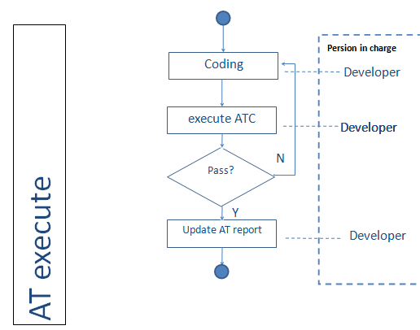

Entries and Exit criteria
  - Entries criteria: the baseline ATC
  - Exit criteria:
  - User interface is designed correctly and all functionalities of the component are working fine.
  - All Acceptance test cases of the tested component are passed.

